REPLY SLIP
Please 'Reply' to ian@netvigator.com before 28th August, 2013
Note. See updates at www.facebook.com/groups/266557333367383/
Dear CAM,
This is to confirm that we, as named in # 1 below, wish to reserve a space at the “Motorcycle Show 2013” on Sunday 27th October, 2013 at Chater Road, Central between 7.00am and 6.30pm. This year Bike Club Stands will be FREE as usual, Shop/Distributor Stands will have a nominal contribution (HK$500.oo) to help cover the Costs of the Show. We agree to follow all Show Rules and Instructions from the CAM Organisers, we understand and accept that failure to do so will result in a HK$3,000 Fine.
- Name of Club or Shop 車會或公司的名稱: .......................................
口club 口shop (please tick as appropriate)
- Contact Person’s name : ....................................................
- Mobile Tel.# : ................ (Speaking English please)
- Email: ....................................................
- Preferred ZONE for your Stand: ........ (see map A,B,C,D,E, or F?)
- Signature/Chop簽署或蓋: ……………………………….……..
(signed/chopped by Club/Shop Official)
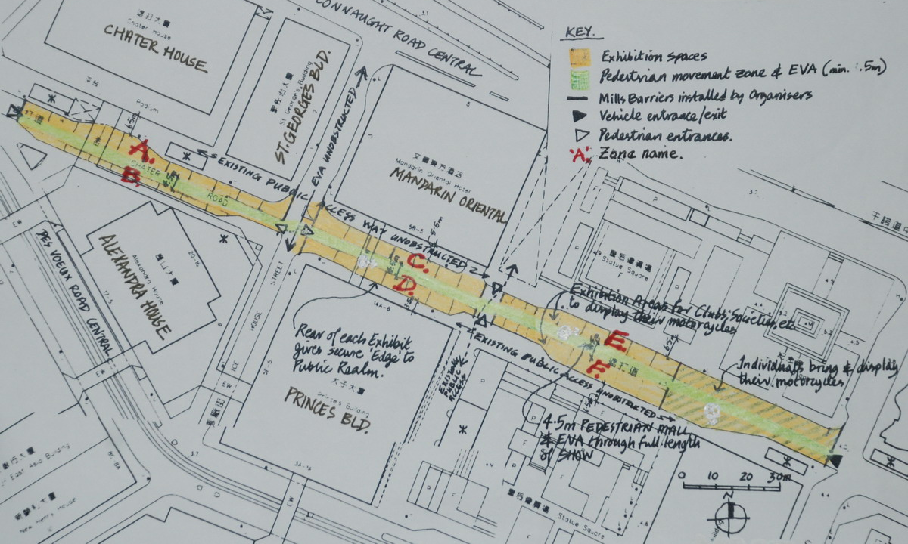
Please Note
As space is limited it will be allocated in a “first come, first served” basis. All participants who take part do so at their own risk. "The Classic Auto-cycle Museum" is a non-profit making Social Club not responsible or liable for loss or damage to you, your vehicles, or your property.

